

Final Year Project

(CCDS25-0028)
Target and Context Aware Transformer for Visual Search Task

Submitted in Partial Fulfillment of the Requirements for the Degree of Bachelor of Computing in Computer Science for the Nanyang Technological University

by

Nguyen Tuan

College of Computing and Data Science

2026

Abstract

The visual search task is essential for humans in everyday activities, such as searching for a cup, toilet paper, or a chair to sit on. Therefore, human visual search tasks are typically goal-driven, requiring individuals to mentally visualize the target and be aware of the surrounding context to locate it. By mimicking human behavior in a human search task, we propose a top-down approach, a target and context-aware transformer architecture that modifies the pretrained vanilla Vision Transformer model (Dosovitskiy et al., 2021) for local modulation (target-aware or target-modulation) and incorporates global modulation (context-aware or context-modulation) by using the attention map produced by a modified version of Context-aware Recognition Transformer Network (CRTNet) (Bomatter et al., 2021). Our model achieved high performance across three image datasets and generalizes well on unlabeled object datasets without requiring fine-tuning.

Acknowledgements

Firstly, I would like to express my sincere appreciation to Dr. Zhang Mengmi, my supervisor, who has provided invaluable guidance throughout this project. Thank you to Xu Wu for providing valuable, supportive materials. Finally, I would like to thank my family members for their physical and emotional support during my Final Year Project.

Table of Contents

Abstract i
Acknowledgements ii
Table of Contents iii
List of Figures v
List of Tables vi
Chapter 1 Introduction 1
Chapter 2 Literature Review 3
2.1 Cognitive visual search theory 3
2.1.1 Feature-Integration Theory 3
2.1.2 Inhibition of Return (IOR) 3
2.1.3 Bottom-up and Top-down approach in Visual Search 4
2.1.4 Context Influence in Visual Search 5
2.1.5 An updated mental model Guided Search 6.0 5
2.2 Computational Visual Search Model 6
2.2.1 Invariant Visual Search Network (IVSN) 6
Chapter 3 Proposed TCT Architecture 10
3.1 Problem statement 10
3.2 Vision Transformer (ViT) 10
3.2.1 Modified ViT with local modulation 10
3.3 Context-aware Recognition Transformer Network (CRTNet) 13
3.3.1 Modified CRTNet with bounding box coordination as an input for positional encoding selection for the target 14
3.3.2 Modified CRTNet without positional encoding for the target image 15
3.3.3 Modified CRTNet with positional encoding for the target image using the cross-attention mechanism 16
3.4 Target-Context Transformer (TCT) 17
Chapter 4 Experiments 18
4.1 Data Augmentation for training CRTNet 18
4.2 Testing CRTNet recognition performance on No Context, No Target 19
4.2.1 Modified CRTNet with bounding box coordination as an input for positional encoding selection for the target 19
4.2.2 Modified CRTNet with positional encoding for the target image using the cross-attention mechanism 20
4.3 TCT model visual search performance on different benchmark datasets 21
4.3.1 COCO-Search18 21
4.3.2 SCEGRAM 22
4.3.3 Natural Design (NatClutter) 22
4.3.4 ContextBreak 23
Chapter 5 Conclusion 25
5.1 Possible Limitations 25
5.2 Contributions 25
5.3 Future directions 26
References 27

List of Figures

Figure 2.1.3.1 Guided Search Version 2.0 Architecture (Wolfe, 1994) 5
Figure 2.1.5.1 Schematic representation of Guided Search 6.0 (Wolfe, 2021) 6
Figure 2.2.1.1 IVSN model schematic (Zhang et al., 2018) 7
Figure 2.2.1.2 Top-down modulation illustration 8
Figure 3.2.1.1 Query Relevance Shape Illustration 12
Figure 3.2.1.2 Local Modulation Operation 13
Figure 3.2.1.1 CRTNet Architecture (Bomatter et al., 2021) 14
Figure 3.3.1.1 CRTNet Positional Encoding with bounding box coordinates as an input 15
Figure 3.3.2.1 CRTNet Positional Encoding for Context only 15
Figure 3.3.3.1 CRTNet Positional Encoding Layer with Cross-Attention Mechanism 16
Figure 3.3.3.1 Global Modulation Operation 17
Figure 4.3.1.1 TCT visual search performance on COCO-Search18 benchmark dataset 21
Figure 4.3.2.1 TCT visual search performance on the SCEGRAM benchmark dataset 22
Figure 4.3.3.1 TCT visual search performance on the naturaldesign benchmark dataset 23
Figure 4.3.4.1 TCT visual search performance on the ContextBreak benchmark dataset 24

List of Tables

Table 4.2.1.1 Test performance of the CRT with bbox as an input in the early epochs and the later epochs 19
Table 4.2.2.1 Test performance comparison of two different CRT models in each epoch 20

Introduction

The visual search task, given a search image and a target image, for example an image of the group of people (search image) and an image of a person’s face in that group (target image), is a challenging problem for most current image recognition models to find target location with exact matching or to find the target when its attributes is incongruent with the surrounding context with lowest number of fixation without retraining or fine-tuning the model architecture, due to the nature of their bottom-up approach which neglect the variance of the object appearance, they can only take a single search image as input, leave out the target image, and find the target object based on the search image saliency from the features extracted from the pre-trained model weights rather than the features extracted from the input target image. Only a limited number of studies have incorporated the given target image into the search process for a top-down approach with zero training to overcome such obstacles. To mimic the human visual search fixation sequence, the visual search task for a computational model requires an attention map as an output, combined with the Inhibition of Return (IOR) method to prevent the model from revisiting attended areas. Based on the fact that the attention mechanism works well with the Transformer model architecture to capture the relationship between the query sequence and the target sequence, we leverage the attention map from the cross-attention of the last Decoder layer output of the modified version of the Context-aware Recognition Transformer Network (CRTNet) (Bomatter et al., 2021) and the attention produced by the self-attention mechanism from the Encoder layer in the modified version of the Vision Transformer (ViT) model (Dosovitskiy et al., 2021) with local modulation between the search image query and target image query to propose a zero-shot Target and Context-aware Transformer (TCT) model architecture to produce an attention map for visual search task.

The main contributions of this paper are as follows:
- Discover the top-down search process in the Invariant Visual Search Network (IVSN) model (Zhang et al., 2018) to understand the computational visual search research process and how the model performs the visual search task.
- Introducing augmentation in the COCO-Search18 dataset (Yang et al., 2020) for training the CRTNet model.
- Evaluate the object recognition accuracy performance of the modified versions of the CRTNet model that include the target bounding box coordinates in the positional encoding layer, trained on the augmented COCO-Search18 dataset.
- Propose different modified versions of the CRTNet model that exclude the target bounding box coordinates from the positional encoding layer to conform to the visual search task constraints.
- Perform visual search task performance using the TCT model on different benchmark datasets.

Literature Review

Cognitive visual search theory

Feature-Integration Theory
Visual search was systematically defined as the process of locating a target in a search scene, display, image, etc., that contains multiple distractors (Treisman & Gelade, 1980). The Feature-Integration Theory (FIT) of Attention, proposed by Treisman and Gelade in 1980, laid the foundation for visual search as a mechanistic model and as a premise for later research in visual search modeling. The theory posits that humans employ three approaches for identifying a unitary target: either through the saliency of the target features in the search image (bottom-up) or via a target-driven approach (top-down), or both simultaneously. The theory also formalized attention as the key requirement in visual search, showing that attention is necessary for feature binding, either through focal attention to focus on a single feature to acknowledge what other features are presented to form an object, or the attention is distributed over the whole group of items that share relevant features. Moreover, Treisman and Gelade also pointed out that humans tend to sequentially scan through a group of items rather than an individual item and efficiently search for the target. Although FIT uncovered the existence and importance of attention in visual search, the theory lacks formalized research on visual attention in relation to the effectiveness of visual search and eye movements.

Inhibition of Return (IOR)
Shortly after the FIT publication, a notable researcher, Posner, conducted experiments and research to fill the gap that previous researchers had not yet scientifically and systematically proven the relationship between attention and eye movement. Posner had clearly defined attention and categorized it into two different types: covert attention and overt attention (Posner, 1980). Covert attention can be defined as the ability selectively attend to the position of the image, scene, or objects without “overt” (explicit) eye or head movement. Overt attention, on the other hand, requires explicit eye fixation or head movement to attain an attention shift. The paper on orienting of attention (Posner, 1980) also emphasizes the importance of covert attention as a means of routing information and controlling search priority, which provides advantages for humans in visual search. This discovery not only consolidates the FIT but also develops on how visual attention impacts human search behavior and efficiency. Later, Posner and Cohen identified an important inhibitory process in the attended search area during visual search and its vital contribution to orienting attention (Posner & Cohen, 1984). Their findings from multiple experiments suggested that humans tend to react more slowly to the previously attended area and demonstrated that the inhibited area is located in the mental map, rather than in retinotopic coordinates, which prevents humans from revisiting the attended area. The discovery laid the groundwork for the search process in later development of bio-inspired calculational and Deep Neural Network (DNN) visual search models, and is regarded as the Inhibition of Return (IOR), which prevents the model from revisiting the attended area.

Bottom-up and Top-down approach in Visual Search
By following up with the FIT, the researcher from Harvard Medical School argued that the visual search task is not purely a bottom-up approach or just a purely top-down approach, but a hybrid combination of both (Wolfe, 1994). In an effort to reconstruct how humans perform visual search, Wolfe proposed a detailed conceptual model architecture Figure 2.1.3.1, which provided a framework and template for later conceptual models and computational deep neural networks. The simulation from the studies revealed a correlation between bottom-up saliency and the distinction among objects, indicating that the contribution of each item to bottom-up activation is inversely related to the similarities between items. In other words, bottom-up saliency emphasizes the distinction of items from their surroundings. In contrast, top-down activation enforces similarity and matching to the categorical properties of the designated target. Finally, the contribution between bottom-up and top-down activation is weighted rather than equally contributed or purely uniformly summed.
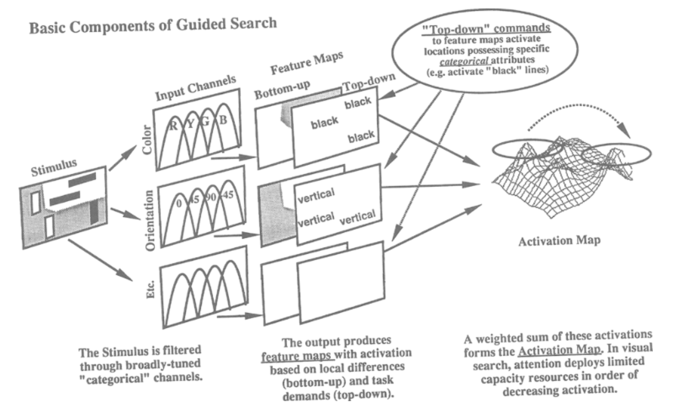
Figure 2.1.3.1 Guided Search Version 2.0 Architecture (Wolfe, 1994)

Context Influence in Visual Search
Previous studies, however, did not account for the effect of scene context on the effectiveness of visual search. To bridge the gap from predecessors, research on context cueing, which focused on implicit learning and memory of visual context guides spatial attention (Chun & Jiang, 1998), proposed that visual context guides human attention to the target in complex visual inputs. The authors argued that context maps are implicitly learned from encountered historical instance which optimize and automate target detection through interaction with visual attention. The authors of the paper also expressed that the knowledge obtained from implicit learning could guide the search process. On the other hand, they also discuss that a model or an intelligence system without a learning mechanism to capture the context information is considered maladaptive.

An updated mental model Guided Search 6.0
By combining all previous discoveries, proposals of visual search frameworks, and previous mental models, Wolfe refined the Guided Search version 2.0 model by adding the scene guidance mechanism so that context information can guide the visual search sequence through “syntactic” guidance (e.g., toasters don’t float) and “semantic” guidance (e.g., toasters don’t belong in the bath room) (Wolfe, 2021). These “syntactic” and “semantic” search guidance are more related to knowledge learned by humans through implicit or explicit learning (context cueing), as discussed by Chun and Jiang (1998), rather than saliency from features in the context scene. Figure 2.1.5.1 illustrates the refinement of the top-down process by showing that the Activated Long-Term Memory (ALTM) holds target templates, which are matched against guiding templates held in the Working Memory (WM), allowing more complex target features and patterns to be detected. This version of the Guided Search model also showed the importance of IOR in preventing re-visitation. The updated model opens up a standardized framework for the development of computational models in the modern stage.

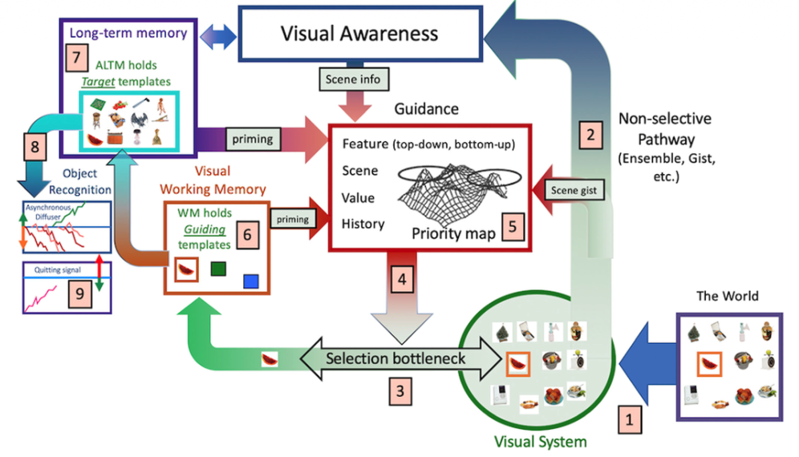
Figure 2.1.5.1 Schematic representation of Guided Search 6.0 (Wolfe, 2021)

Computational Visual Search Model

Invariant Visual Search Network (IVSN)
Inspired by biological cognitive function in visual search, IVSN architecture is designed with a top-down approach mimicking frontal cortical structure projecting onto visual cortex structures through a first-order approximation to produce the attention map (Zhang et al., 2018). From the model architecture represented in Figure 2.2.1.1, we can see two independent Convolutional Neural Networks (CNNs) used VGG16 architecture (Simonyan & Zisserman, 2014) as specified in the paper, but only keep the structure up to layer 30 ($VGG{16}_{30}$) (the ReLU activation outputs of the last convolutional layer), the CNN that takes the target image as an input has one more max pooling layer that summarize the importance features of the target ($VGG{16}_{31}$).
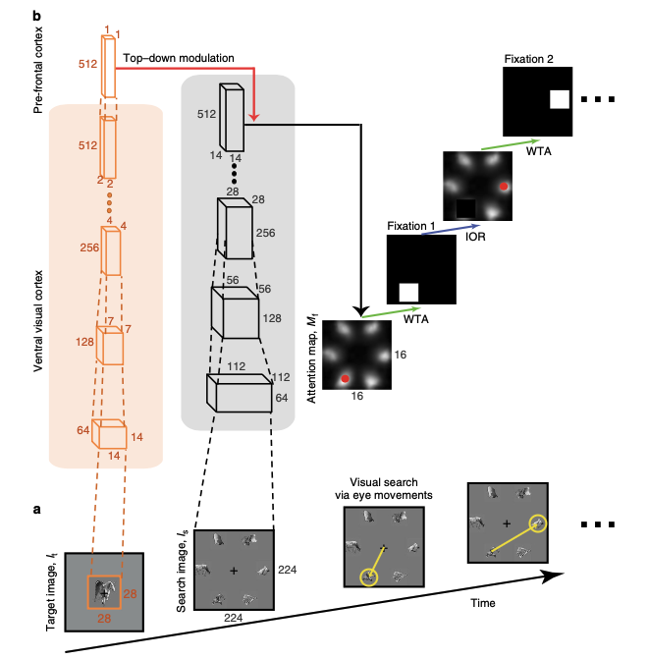
Figure 2.2.1.1 IVSN model schematic (Zhang et al., 2018)

The schematic can be represented in the following illustrations:
Given $I_{t}∈R^{3×28×28}, I_{s}∈R^{3×224×224}$
$$I_{t}^{'}=VGG{16}_{31}\left(I_{t}\right)$$
$$I_{s}^{'}=VGG{16}_{30}\left(I_{s}\right)$$
Where $I_{t}^{'}∈R^{512×1×1},I_{s}^{'}∈R^{512×14×14}$
To generate an attention map with first-order similarity approximation, the model conducts a dot product $I_{t}^{'}$ with each entry of $I_{s}^{'}$, refer to Figure 2.2.1.2 (the Figure is for method illustration purposes only, where the dimensions of $I_{s}^{'}$ differ from the discussed dimensions)
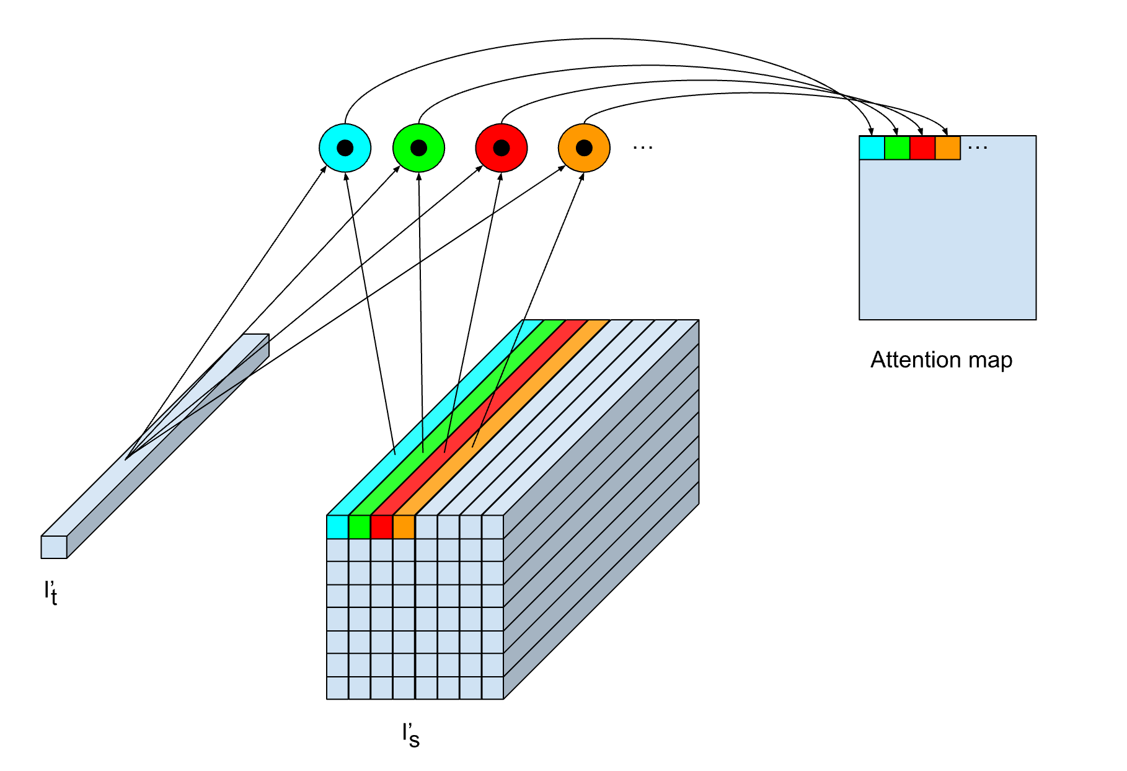
Figure 2.2.1.2 Top-down modulation illustration
The attention map is then resized to match the input context image size to conduct searching by using the following algorithm:

Algorithm Visual Search with normalized positive entries Attention Map and IOR
Function visual_search(attention_map, IOR_size, target_bbox):
While sum(attention_map) != 0:
y, x = entry indices of highest value in attention map
if x, y inside target_bbox:
return x, y
else:
IOR_h = IOR_size[0]
IOR_w = IOR_size[1]
# Inhibition of Return
attention_map[y-IOR_h/2:y+IOR_h/2, x-IOR_w/2:x+IOR_w/2] = 0
return -1, -1

IVSN model not only validated the classical theories proposed by cognitive visual search researchers, especially Guided Search 2.0 (Wolfe, 1994), but also demonstrated the capacity of realizing mental models through DNN for visual search in natural scenes. However, the paper did not stop at the cognitive theory realization; the other main idea of the research is zero-shot invariant, which shows a very strong capacity of the model to search for the same category target with different appearances in the search scene without retraining the CNN backbone (VGG16). By leveraging the powerful computational capacity of DNN, the paper broke free from traditional visual search, which required subjects to find an exact match to the given target in complex natural scenes, rather the subjects are required to find similar target category which are more closely to human visual search ability, and opened up a fundamental ground for transfer learning and zero-shot model architectures for visual search task.

Proposed TCT Architecture

Problem statement
Similar to how Guided Search 6.0 refined Guided Search 2.0, previous computational visual search models did not account for contextual and pre-learned knowledge from the surroundings, providing “syntactic” and “semantic” guidance for visual search. Given the context-aware properties of the CRTNet in object detection (Bomatter et al., 2021), we will modify the CRT architecture into different versions to combine with ViT model (Dosovitskiy et al., 2021) and perform transfer learning via global modulation within the TCT model.

Vision Transformer (ViT)
A previous study by the Google research team in 2017 demonstrated strong performance of the Attention mechanism in the Transformer architecture in Natural Language Processing (Vaswani et al., 2023). Later, in 2021, Google researchers discovered a way to represent the image as tokens by dividing the input image into 16-by-16 patches and encoding them into vectors (tokens), where the channel dimension represents the token's embedding value. The tokens are then processed like a sequence of word tokens (Dosovitskiy et al., 2021).

Modified ViT with local modulation
By introducing the local modulation mechanism into the ViT model, our proposed architecture enables the model to mimic focal attention, guiding the visual search process. The local modulation is built using the attention mechanism, using the query tensor from the target image as a query input, and the query tensor from the context image as the key input. Local modulation is conducted on a layer basis, for the last_n_layers, a user-specified parameter. A local modulation for the layer $l$, target query input at the layer $l$ $Q_{t}^{\left[l\right]}$, and context query input at the layer $l$ $Q_{c}^{\left[l\right]}$ are described mathematically as follows:

We have:
$$Q_{t}^{\left[l\right]}∈R^{\text{num_attention_head} × \left(\text{target_sequence_len}-1\right) × \text{attention_head_size}}$$
$$Q_{c}^{\left[l\right]}∈R^{\text{num_attention_head} × \left(\text{context_sequence_len}-1\right) × \text{attention_head_size}}$$

Where:
$$\text{\# image patches}=\frac{\text{image_area}}{\text{patch area}}=\frac{H×W}{P×P}$$
$$\text{target_sequence_len}=\text{\# target image patches}+1[CLS token]$$
$$\text{context_sequence_len}=\text{\# context image patches}+1[CLS token]$$

The query_relevance is defined as:
$$\text{query_relevance}=\frac{Softmax\left(Q_{t}^{\left[l\right]}{Q_{c}^{\left[l\right]}}^{T}\right)}{\sqrt{\text{attention_head_size}}}$$
We then keep the highest value along the dimension whose size is $\left(\text{target_sequence_len}-1\right)$ (i.e., the maximum value in each column if the tensor is represented in ($\text{features}×\text{columns}×\text{rows}$) format). Refer to Figure 3.2.1.1 for the query relevance shape.
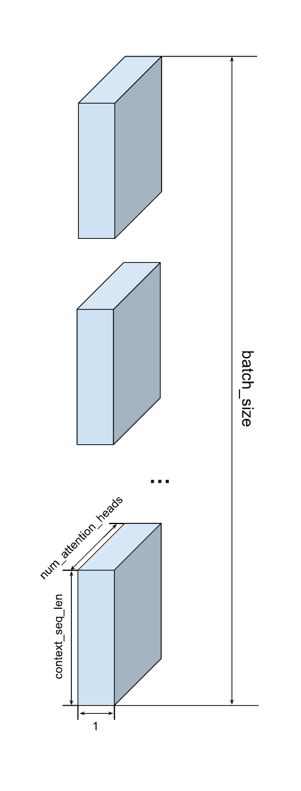
Figure 3.2.1.1 Query Relevance Shape Illustration
This query_relevance will then be used to mask/scale (element-wise multiplication) the encoder attention output of the context in that layer before the attention is multiplied by the Value Tensor of the context in the same layer.
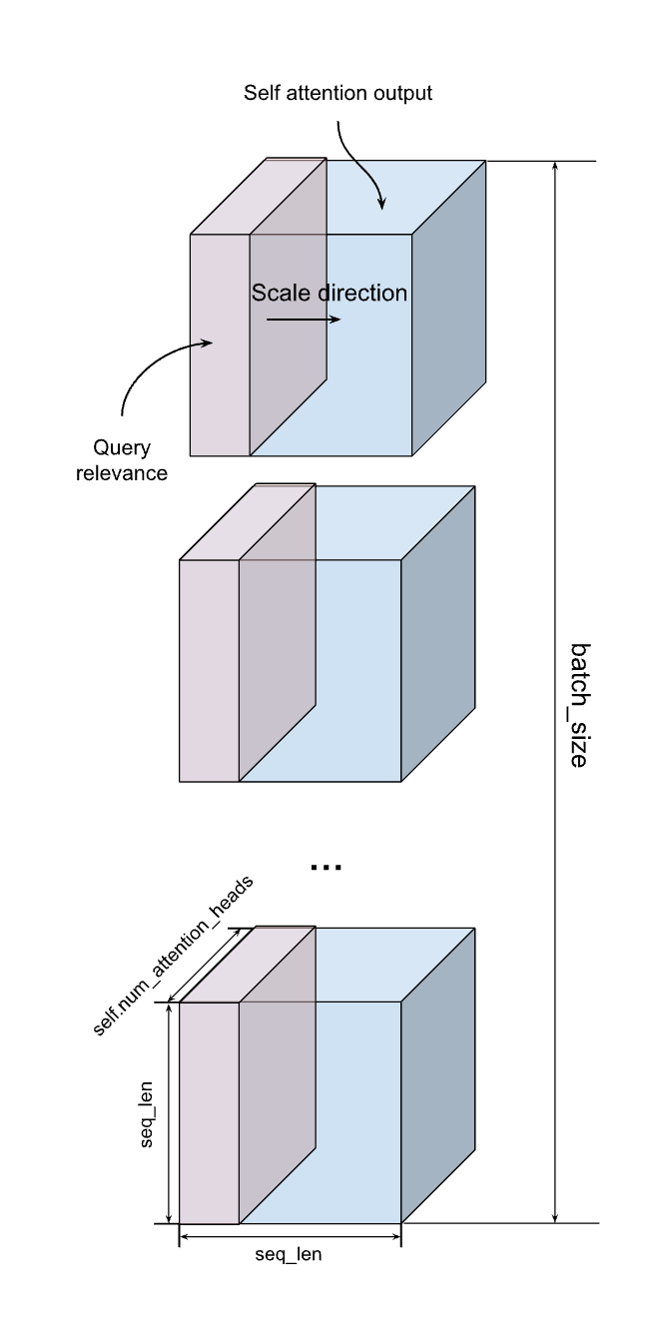
Figure 3.2.1.2 Local Modulation Operation

Context-aware Recognition Transformer Network (CRTNet)
The original work of the CRTNet is to study how context influences object recognition (Bomatter et al., 2021). For instance, by providing an image of the mug and the context, such as an image of the mug on the table in the kitchen, the authors studied how context affects the model’s final decision. The original model architecture is shown in Figure 3.2.1.1.
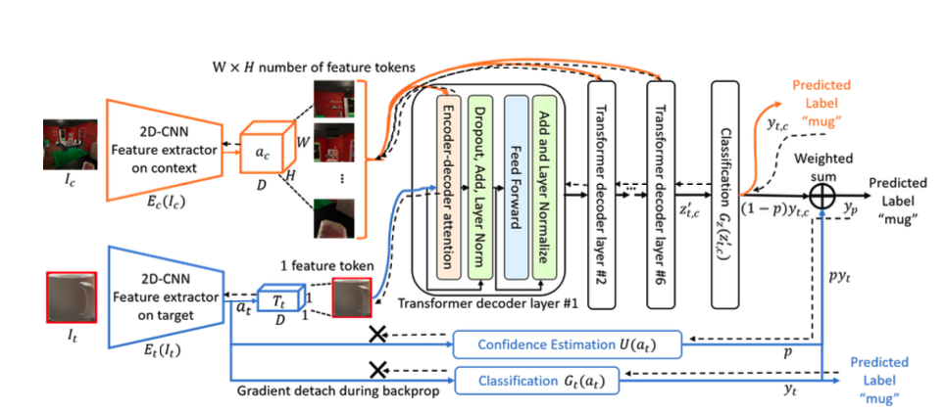
Figure 3.2.1.1 CRTNet Architecture (Bomatter et al., 2021)

Modified CRTNet with bounding box coordination as an input for positional encoding selection for the target
To allow the model to make use of the full information from the context and learn common knowledge of natural scenes, the CRTNet model is modified by removing the classifier $G_{t}(a_{t})$ and the confidence estimator $U(a_{t})$; other parts of the model are kept intact. Therefore, model outputs simply rely on the classifier $G_{z}(z_{t,c}^{'})$, in other words, $p=0$. The model is then further trained on different augmented data transformations, which will be discussed in Chapter 4 to improve its context reasoning and invariance to target appearance (i.e., targets of the same category, differing in appearance, exist in the same contexts will give the same prediction). Since the other parts of the model are kept intact, the Positional Encoding (PE) layer still requires bounding box coordinates as an input to show the position of the target input in the context scene, helping the model to select the appropriate PE entry from the context PE and add it to the target token, as shown in the code snippet below.

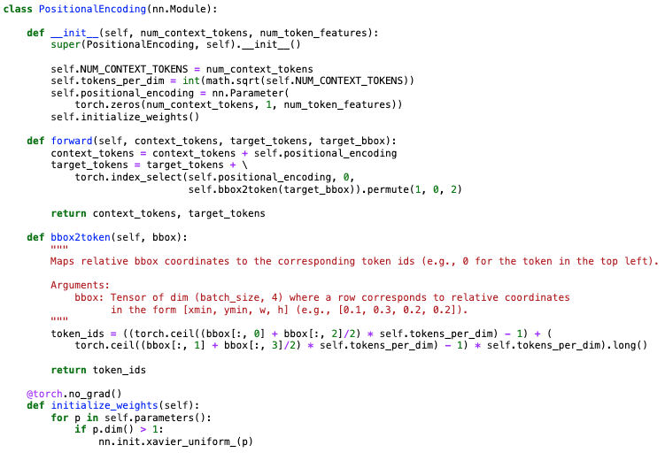
Figure 3.3.1.1 CRTNet Positional Encoding with bounding box coordinates as an input
This is only appropriate for object recognition since the model is allowed to know the position of the target to predict its category. However, providing the target coordinates in a visual search task is inappropriate and requires some other solutions.

Modified CRTNet without positional encoding for the target image
One naïve solution is to remove the value added to the target token, so we will not need to provide the bounding box coordinates.

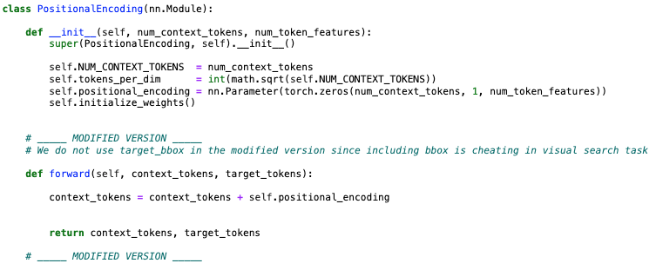
Figure 3.3.2.1 CRTNet Positional Encoding for Context only
Therefore, the PE layer will only apply encoding to the context tokens.

Modified CRTNet with positional encoding for the target image using the cross-attention mechanism
By effectively removing the bounding box coordinates as input into the CRTNet, the model tends to lose the “sense” of the target coordinates in the context scene. To reintroduce the target coordinates without requiring additional inputs, the model’s architecture is adjusted by adding a lightweight attention layer, with the target tokens as the Query input, and positional encoding as Key and Value inputs to the attention layer to generate a bounding box token index selection from the surrounding context tokens and apply appropriate positional encodings.

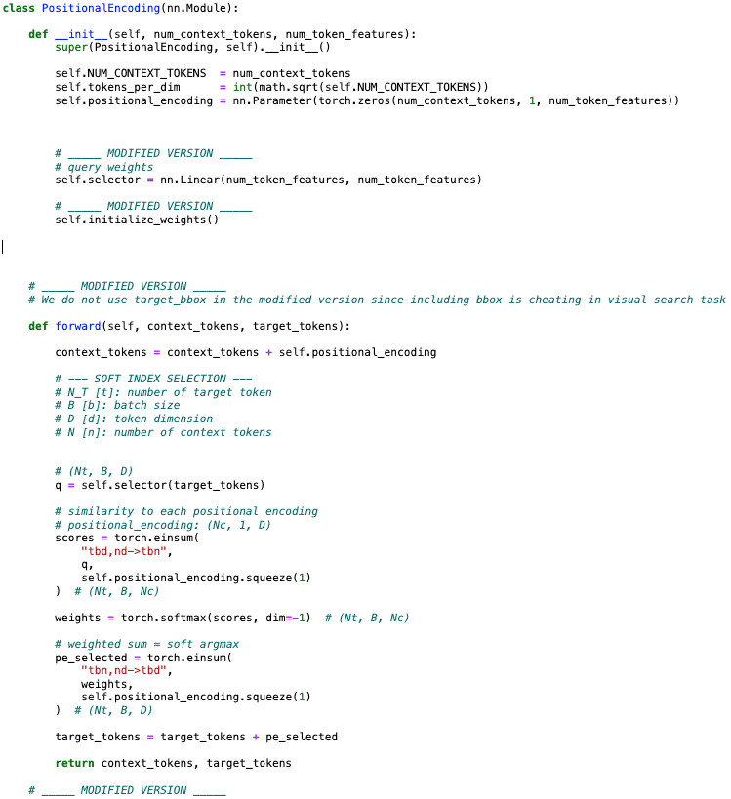
Figure 3.3.3.1 CRTNet Positional Encoding Layer with Cross-Attention Mechanism

Target-Context Transformer (TCT)
By leveraging knowledge from the CRT model and focal attention from the ViT model, we architect a structure that allows global attention from the CRT model to participate in the visual search process. The global modulation in the TCT model is an element-wise product of the CRT attention and the ViT Encoder block's output tensor (this operation is applied only once on a specified encoder block).
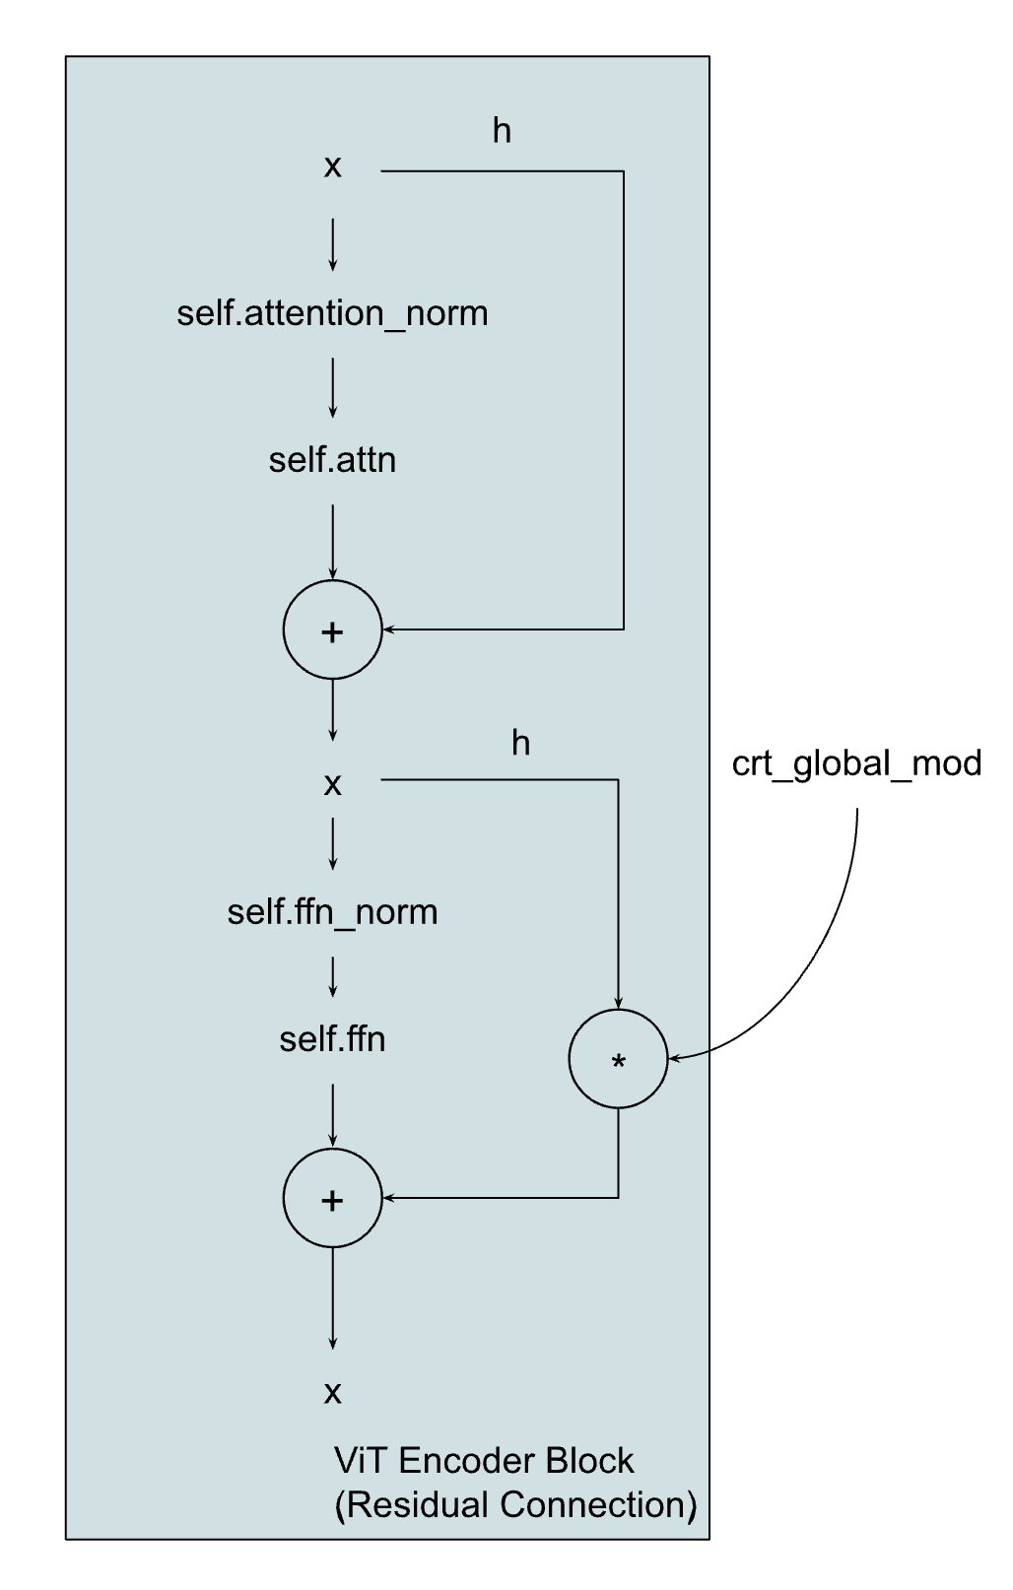
Figure 3.3.3.1 Global Modulation Operation

The model implementation is an exposed structure rather than a class for flexibility in different hyperparameter tuning experiments.

Experiments

In the experiments listed below, we consider two CRT model architectures: one that takes a bounding box as input to guide the PE, and one that learn to guide the PE attention for the target token via the attention mechanism due to timing constraints and resource limitations.

Data Augmentation for training CRTNet
To improve training of the CRTNet for the image recognition task and encourage the model to leverage the cross-attention mechanism within the transformer-based architecture, we introduce different augmentations to both the context and target input images from a subset of 18 image categories in the COCO dataset (Lin et al., 2015). The context-target image pairs will be randomly selected based on the following options for each pair of inputs:
- Context options:
  - Original image with original target inside the context image. (1)
  - Original image with a random target of the same category inside the target region. (2)
  - Original image with a black image covering the target region. (3)
- Target options:
  - Original target image. (A)
  - Random target image of the same category as the target image. (B)
  - Fully Black image. (C)
Therefore, there are 9 combinations to form input pairs to train the model using Cross-Entropy Loss for the classification task.

Testing CRTNet recognition performance on No Context, No Target
The CRT model is tested on the test dataset using the (3)(C) augmented version (No Context, No Target) of the COCO-Search18 dataset to assess the performance.

Modified CRTNet with bounding box coordination as an input for positional encoding selection for the target
The model’s attention output behaves differently in training phases. The testing phase in the early training stage reveals that the attention mechanism from the last decoder layers shows a comprehensive attention map that is possible to contribute to the recognition task, and attention produced by previous layers tends to be distributed uniformly. In the later training epochs, the performance of the model in the testing phase keeps increasing, but the attention map in all the layers is approaching a uniform distribution, which could imply that preserving the original context tends to improve the recognition performance when training with the lack of target information (target image is blacked out), the recognition prediction is entirely based on the context information. Since the CRTNet task in this paper is to act as an “advisor” (global/context guidance) for the ViT model, and the combination of the later trained CRT model’s attention map could hinder the TCT model’s visual search performance due to its uniform distributed property, we will use an early checkpoint from the early epochs to transfer learning to the TCT model.

Epoch | Test Accuracy
7 | 70.38%
24 | 71.56%
221 | 85.15%

Table 4.2.1.1 Test performance of the CRT with bbox as an input in the early epochs and the later epochs

Modified CRTNet with positional encoding for the target image using the cross-attention mechanism
Since we removed the introduction of bounding box coordination of the target into the positional encoding phase, and replaced it with the simple attention mechanism to select the correct image patch index from the context tokens to select the PE, the CRT model’s cross-attention layer is forced to “work harder” to learn to attend more to other factors in the context tokens to generate a more comprehensive attention map that potentially help the context guidance for the visual search task of the TCT model. In fact, the modified version of the CRT model tends to occasionally improve the performance of the TCT model, such as visual search task performance on the SCEGRAM (Öhlschläger & Võ, 2017), as shown in Figure 4.3.2.1. Moreover, we observe faster convergence to higher accuracy than the bounding box input-guided CRT model in the object recognition task from the COCO-search18 test dataset Table 4.2.2.1.

Epoch | Test Accuracy  (CRT cross-attention PE) | Test Accuracy  (CRT bbox-guided PE)
7 | 75.44% | 70.38%
24 | 85.31% | 71.56%

Table 4.2.2.1 Test performance comparison of two different CRT models in each epoch

TCT model visual search performance on different benchmark datasets
Through many iterations to find the best epoch checkpoint for each CRT model architecture in visual search performance of the TCT model, the best epoch for the bounding box guide CRT model (denoted as CRT bbox) is epoch 7, and the best epoch for the no bounding box cross-attention guide CRT model (denoted as CRT no bbox) is epoch 24. We will use the best checkpoints to compare the two CRT models’ contributions to the TCT model performance on different benchmark datasets.
The TCT model’s cumulative performance graph in the following experiments on different benchmark datasets can be expressed as follows: the cumulative performance of a certain number of fixations is the accuracy of the model to find the correct target with no more than that number of fixations.

COCO-Search18
The COCO-Search18 dataset is a subset of the COCO dataset (Lin et al., 2015) that only contains 18 categories, which are also further filtered to those that are feasible for both humans and machines to recognize the target in the given context in terms of brightness and size. Figure 4.3.1.1 shows that both TCT architectures perform better than the chance model (RANDOM). The graph also illustrates that both TCT architectures have similar performance, where the CRT bbox has a slightly better performance.
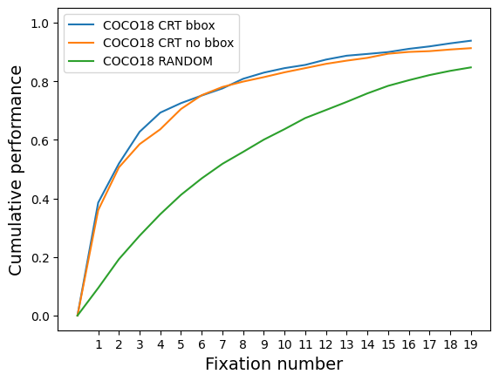
Figure 4.3.1.1 TCT visual search performance on COCO-Search18 benchmark dataset

SCEGRAM
The SCEGRAM dataset (Öhlschläger & Võ, 2017) is a collection of images that are inconsistent in both syntactic and semantic aspects; such a dataset challenges the model’s ability to find targets that are inconsistent with the surrounding context. Figure 4.3.2.1 illustrates that both architectures outperform the chance model (RANDOM) and also points out the TCT model that relies on the guidance of the CRT no bbox architecture has a notably better performance on a higher number of fixations. Besides, the higher TCT models' performance over the chance model shows the capability of the models to handle inconsistencies in both syntactic and semantic context.

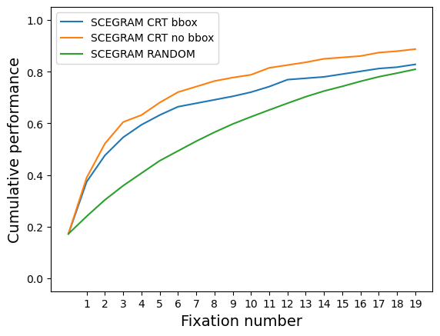
Figure 4.3.2.1 TCT visual search performance on the SCEGRAM benchmark dataset

Natural Design (NatClutter)
The NatClutter dataset was originally introduced in the IVSN paper (Zhang et al., 2018) to evaluate the model’s ability to identify the target among numerous similar distractors in terms of size and shape across different natural scenes, which challenge the model to find the exact match of the target in the complex natural context like finding a person face in a group of people. Both TCT architectures that depend on the guidance of CRT bbox and CRT no bbox perform better than the chance model (RANDOM), Figure 4.3.3.1. On top of that, both models have comparable performance on the benchmark dataset, while the TCT model guided by CRT no bbox has slightly higher accuracy in a smaller number of fixations, but is overshadowed by the one that is guided by CRT bbox in a higher number of fixations.
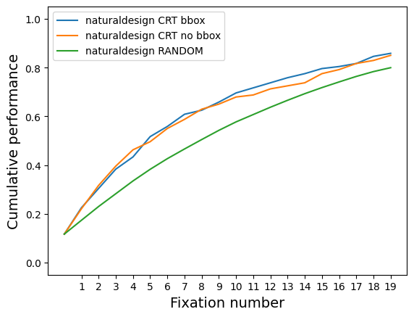
Figure 4.3.3.1 TCT visual search performance on the naturaldesign benchmark dataset

ContextBreak
Finally, we introduce a new benchmark dataset to compare the performance of two model variations. The ContextBreak dataset generates multiple views of the same context by varying camera angles within a 3D simulation environment. The purpose of this dataset is to let the model illustrate its ability to find the same target in the same context, but in different angles of the same context. This replicates human behaviour in searching in the natural scene, where we conduct overt attention, which requires explicit eye or head movements. Figure 4.3.4.1 shows TCT models significantly outperform the chance model (RANDOM) by a large margin, which indicates the sub-human performance of the model on the benchmark. In general, both variances of the TCT model have similar performance in all ranges of fixations, where CRT no bbox has slightly higher performance on the first half of the number of fixations and is surpassed by CRT bbox variance in the second half of the illustrated number of fixations.

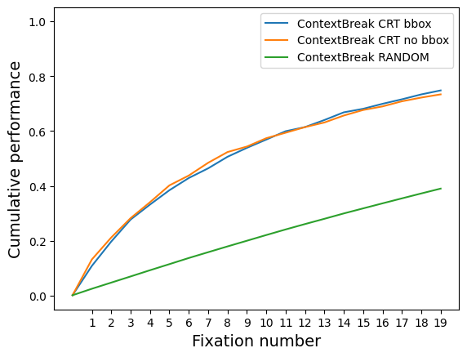
Figure 4.3.4.1 TCT visual search performance on the ContextBreak benchmark dataset

Conclusion

Possible Limitations
Since the TCT model is the combination of the CRT model and the ViT model, using the global modulation operation as a bridge to allow CRT’s attention output to participate in the attention generation process of the ViT model, and each model is trained on a different dataset, it is difficult to mathematically explain why CRTNet attention map can have positive impact on ViT attention map through global modulation, as the global modulation of the CRT attention interferes with the process of generating attention in the intermediary encoding layer of the ViT model. Moreover, the selected encoder layer for global modulation and the number of the last n layers for local modulation within the ViT model are determined through an iterative process rather than being mathematically proven. Those ambiguities require further examination to determine the underlying reasons and the relation among the attention output from the i^{th} layer of the CRT model, the selected j^{th} Encoding layer of the ViT model, and the last n encoding layers for local modulation in the ViT model.

Contributions
Through logic examination and code inspection, as well as different experiment iterations, we were able to restructure the CRT model architecture to be suitable for the visual search task by removing the bounding box coordination as an input to the model and replacing it with a weighted average of the context PE tokens by using the attention output from the lightweight attention layer inside the PE layer as weights. We then force the CRT model to generate the attention map from the context image that contributes to the object recognition task through data augmentation methods specified in 4.1. Besides, we also modified the ViT architecture to have additional local modulations for the last n encoder layers. Finally, the TCT model is constructed by combining the modified CRT model with the modified ViT model through global modulation of the CRT attention map and the attention output of the selected encoder layer in the residual connection of the ViT’s Transformer architecture. We then perform visual search on the TCT model across four benchmark datasets, and the bounding-box-based TCT model serves as a benchmark for relative performance comparison with the proposed TCT model.

Future directions
Despite impressive performance on various benchmark datasets, there is still room for improvement. By treating the CRT and the ViT as the building blocks of the ViT model, we can examine the replaceability of each building block with other architectures by comparing models’ performance on benchmark datasets. We can further combine two or more transformer architectures either through the same global modulation channel of one final ViT architecture or through the “waterfall” global modulation of each model down to the final ViT model to improve the performance. Finally, although this paper considers zero-training and transfer learning of the CRT and ViT models, we can train the whole TCT model on the recognition task and conduct transfer learning on the visual search task when the hardware development is capable of such a large model. Provided with such a powerful model for the visual search task, we can leverage its ability to identify resources in a satellite image or to locate a person in a crowd, etc., which can significantly reduce the time and effort required for human visual search tasks.

References

Bomatter, P., Zhang, M., Karev, D., Madan, S., Tseng, C., & Kreiman, G. (2021). When Pigs Fly: Contextual Reasoning in Synthetic and Natural Scenes. 2021 IEEE/CVF International Conference on Computer Vision (ICCV), 255–264. https://doi.org/10.1109/ICCV48922.2021.00032
Chun, M. M., & Jiang, Y. (1998). Contextual Cueing: Implicit Learning and Memory of Visual Context Guides Spatial Attention. Cognitive Psychology, 36(1), 28–71. https://doi.org/10.1006/cogp.1998.0681
Dosovitskiy, A., Beyer, L., Kolesnikov, A., Weissenborn, D., Zhai, X., Unterthiner, T., Dehghani, M., Minderer, M., Heigold, G., Gelly, S., Uszkoreit, J., & Houlsby, N. (2021). An Image is Worth 16x16 Words: Transformers for Image Recognition at Scale (arXiv:2010.11929). arXiv. https://doi.org/10.48550/arXiv.2010.11929
Lin, T.-Y., Maire, M., Belongie, S., Bourdev, L., Girshick, R., Hays, J., Perona, P., Ramanan, D., Zitnick, C. L., & Dollár, P. (2015). Microsoft COCO: Common Objects in Context (arXiv:1405.0312). arXiv. https://doi.org/10.48550/arXiv.1405.0312
Öhlschläger, S., & Võ, M. L.-H. (2017). SCEGRAM: An image database for semantic and syntactic inconsistencies in scenes. Behavior Research Methods, 49(5), 1780–1791. https://doi.org/10.3758/s13428-016-0820-3
Posner, M. I. (1980). Orienting of Attention. Quarterly Journal of Experimental Psychology, 32(1), 3–25. https://doi.org/10.1080/00335558008248231
Posner, M. I., & Cohen, Y. (1984). Components of Visual Orienting. In H. Bouma & D. G. Bouwhuis (Eds.), Attention and Performance X (pp. 531–556). Lawrence Erlbaum Associates.
Simonyan, K., & Zisserman, A. (2014). Very Deep Convolutional Networks for Large-Scale Image Recognition (Version 6). arXiv. https://doi.org/10.48550/ARXIV.1409.1556
Treisman, A. M., & Gelade, G. (1980). A feature-integration theory of attention. Cognitive Psychology, 12(1), 97–136. https://doi.org/10.1016/0010-0285(80)90005-5
Vaswani, A., Shazeer, N., Parmar, N., Uszkoreit, J., Jones, L., Gomez, A. N., Kaiser, L., & Polosukhin, I. (2023). Attention Is All You Need (arXiv:1706.03762). arXiv. https://doi.org/10.48550/arXiv.1706.03762
Wolfe, J. M. (1994). Guided Search 2.0 A revised model of visual search. Psychonomic Bulletin & Review, 1(2), 202–238. https://doi.org/10.3758/BF03200774
Wolfe, J. M. (2021). Guided Search 6.0: An updated model of visual search. Psychonomic Bulletin & Review, 28(4), 1060–1092. https://doi.org/10.3758/s13423-020-01859-9
Yang, Z., Huang, L., Chen, Y., Wei, Z., Ahn, S., Zelinsky, G., Samaras, D., & Hoai, M. (2020). Predicting Goal-Directed Human Attention Using Inverse Reinforcement Learning. 2020 IEEE/CVF Conference on Computer Vision and Pattern Recognition (CVPR), 190–199. https://doi.org/10.1109/CVPR42600.2020.00027
Zhang, M., Feng, J., Ma, K. T., Lim, J. H., Zhao, Q., & Kreiman, G. (2018). Finding any Waldo with zero-shot invariant and efficient visual search. Nature Communications, 9(1), 3730. https://doi.org/10.1038/s41467-018-06217-x

